**CHAPTER 1**

**INTRODUCTION**

Simplish is an innovative online course platform designed to bridge the gap between learners and educators in the digital age. Our platform enables users to seamlessly register, log in, and purchase courses, while providing educators with the tools to create, manage, and share their expertise. With a focus on user-friendly interfaces, robust security measures, and comprehensive course management features, Simplish aims to revolutionize online education.

Our vision is to create a globally accessible platform where knowledge and education are democratized. We aim to empower learners from all walks of life to achieve their educational goals and foster a community of continuous learning and growth.

Simplish offers a straightforward and secure registration process for both learners and educators. New users can easily sign up by providing essential information such as their name, email address, and a secure password. To enhance security, we implement email verification during the registration process, ensuring that only legitimate users gain access to the platform..

Security is paramount at Simplish. We have implemented a robust authentication system that includes multi-factor authentication (MFA). Users must log in with their correct ID and password, complete a CAPTCHA verification, and enter a one-time password (OTP) sent to their registered email. This multi-layered approach ensures that user accounts are protected against unauthorized access. Educators on Simplish can easily register, log in, and create courses using our intuitive course management system. They can upload course materials, set pricing, and manage course content through a streamlined dashboard. Additionally, educators can interact

**CHAPTER 2**

**OBJECTIVE**

The primary objective of Simplish is to create a dynamic and accessible online course platform that serves the needs of both learners and educators. By providing a comprehensive set of features and tools, Simplish aims to:

• **Enhance Accessibility to Education:**

* Simplish strives to break down geographical and financial barriers to education by offering a wide range of affordable and accessible courses to learners globally.

• **Facilitate Effective Learning:**

* We aim to provide a rich learning experience through high-quality course content, interactive elements, and supportive community features that promote engagement and retention.

• **Support Educators:**

* Simplish is dedicated to empowering educators by offering an easy-to-use platform for course creation, management, and monetization. We provide tools and resources that enable educators to focus on delivering quality education while we handle the technical complexities.

• **Ensure Security and Privacy:**

* We prioritize the security and privacy of our users by implementing robust authentication methods and secure payment systems. Simplish is committed to safeguarding user data and providing a safe online learning environment.

**2.2 LITERATURE SURVEY**

The online education sector has witnessed significant growth over the past decade, driven by technological advancements and the increasing demand for flexible learning options. To understand the current landscape and identify best practices for developing Simplish, we conducted a comprehensive literature survey of existing research, platforms, and trends in online education.

**Growth of Online Education**

Research indicates that the global online education market has been expanding rapidly, with projections estimating its value to reach $350 billion by 2025 (Zhao et al., 2020). This growth is attributed to factors such as the proliferation of high-speed internet, the rise of mobile learning, and the increasing acceptance of online credentials by employers.

**Key Components of Successful Online Learning Platforms**

**User Experience and Interface Design**

Studies have shown that the user experience (UX) and interface design play a crucial role in the success of online learning platforms (Hsu et al., 2018). A well-designed interface that is intuitive and easy to navigate can significantly enhance user engagement and satisfaction. Simplish aims to incorporate best practices in UX/UI design to provide a seamless and enjoyable experience for both learners and educators.

**Course Quality and Content Delivery**

The quality of course content is paramount in online education. Research highlights the importance of interactive and multimedia elements in enhancing learning outcomes (Clark & Mayer, 2016). Simplish will leverage various content formats, including videos, quizzes, and interactive modules, to create engaging and effective learning experiences.

The rapid growth of the online education industry has created numerous opportunities for learners and educators alike. However, several challenges persist that hinder the effectiveness and accessibility of online learning. Simplish aims to address these challenges by providing a comprehensive, user-friendly, and secure platform for both learners and educators.

**2.1 Problem Statement**

### Challenges in the Current Online Education Landscape

1. **Accessibility Issues:**
   * Many existing platforms have high costs associated with their courses, limiting access for learners from low-income backgrounds.
   * There is a lack of accessibility features for learners with disabilities, making it difficult for them to engage with course content effectively.
2. **Inconsistent Course Quality:**
   * The quality of courses can vary significantly, particularly on platforms with an open marketplace model. This inconsistency can lead to poor learning outcomes and user dissatisfaction.

**Security and Privacy in Online Education**

With the rise of online learning, concerns about data security and privacy have also increased. Research emphasizes the need for robust security measures to protect user data and ensure the integrity of online transactions (Nguyen et al., 2020). Simplish implements multi-factor

**2.2 Existing System:**

## Existing System

### Overview of Current Online Learning Platforms

The current landscape of online learning is populated by various platforms, each with its own strengths and weaknesses. Prominent examples include Coursera, Udemy, and Khan Academy. While these platforms have made significant contributions to the field of online education, they also exhibit several limitations that Simplish aims to overcome.

### Coursera

#### Strengths:

* **High-Quality Courses:** Coursera partners with top universities and institutions to offer high-quality courses, specializations, and degree programs.
* **Certification:** Learners can earn certificates and degrees that are recognized by employers and academic institutions.
* **Wide Range of Subjects:** A broad array of subjects and disciplines are covered, catering to diverse learning needs.

#### Weaknesses:

* **High Cost:** Many courses and programs on Coursera are expensive, creating a financial barrier for some learners.
* **Limited Interactivity:** While the platform offers video lectures and quizzes, the level of interactivity and engagement in many courses is limited.

### Udemy

#### Strengths:

* **Affordability:** Udemy offers a wide range of courses at relatively low prices, making education more accessible.

**2.3 Proposed System:**

Simplish is designed to address the limitations and challenges identified in existing online learning platforms by providing a comprehensive, user-friendly, and secure environment for both learners and educators. The proposed system aims to enhance accessibility, ensure high-quality course delivery, and foster a collaborative learning community.

**1. Enhanced Accessibility**

**Affordability:**

* Simplish will offer a range of free and affordable courses to ensure that learners from diverse financial backgrounds can access quality education. Additionally, we will provide **2. Consistent Course Quality**

**Curated Course Content:**

* Simplish will employ a rigorous vetting process for course content to ensure high standards. Courses will be reviewed by subject matter experts before being made available to learners.

**Interactive Learning:**

* The platform will incorporate multimedia elements, including videos, quizzes, interactive simulations, and discussion forums, to enhance learner engagement and retention.

**CHAPTER 3**

**COMPANY OVERVIEW**

**3. INTRUDUCTION**

Athreya Technologies is a Bangalore based Company who has experience in vast areas of Technology with individuals being full stack developers. Along with the Technical Expertise Athreya Technologies with rich industry expertise in handling R&D teams associated with $150M Revenue and team sizes as large as 200 plus engineers. The team has experience in people program and project management of medium to large Products from various models starting from waterfall to scaled Agile.Athreya Technologies have a team of experts who are here to help you develop Successful software’s to make your workflows simple.

* A director of operations and finance is in charge of overseeing and spearheading business and financial operations, ensuring efficiency and smooth workflow. Their responsibilities revolve around performing research and analysis to identify the best practices to optimize operations, coordinating with different departments to gather data, conducting research and analysis to identify new business and investment opportunities, and monitoring the progress of various projects and programs.
* Finance operations directors also may supervise budget development, financial reporting, and systems management, as well as finance staff, while driving business processes to improve efficiency and meet organizational goals.

Depending on the employer and industry, the finance operations director may approve credit and billing terms for contracts. In addition, they may be responsible for managing internal systems used for recording revenue and compliance with tax and regulatory requirements

**3.1 VISION AND MISSION OF ATHREYA TECHNOLOGIES**

**Vision**

* Unleashing the power of innovation and software to make life simple. There by creating a world class-innovation center and a dedicated employer.

**Mission**

* To provide Jobs, Technology and Coaching to the aspiring candidates along with achieving our business vision and becoming profitable business.

**Values**

* Athreya Technologies believe in the following core values (QSTTI)
* Quality

• Simplicity

• Team up to win

• Trust and Integrity

* All the staff members have been covered through workshops to give complete insights of the group values.
* These values provide strong foundation on which our practices and business decisions are based.

# 3.2 Project, Program and People Management

Along with the Technical Expertise Athreya Technologies with rich industry expertise in handling R&D teams. The team sizes as large as 200 plus engineers. The team has experience in people program and project management of medium to large Products from various models starting from waterfall to scaled Agile.

Athreya Technologies have a team of experts who are here to help you develop Successful software’s to make your workflows simple.

# Knowledge

As organization develops, funds to be reserved towards coaching students from ruralcolleges, help them establish themselves as leaders.We are individuals with over 20+ years of industry experience.

We are starting with the software services to create the continuous flow of funds to runthe organization. here are many ideas we have, needs additional hands and fresh minds to create conceptsand implement.

## Software Services & Solutions

On board the Digital Transformation journey that the globe is witnessing with services and solutions provided to various platforms for example AEQUS and HDMC to start

# 3.2.1 Here is how Athreya Technologies plan to grow in people

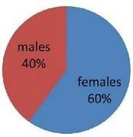

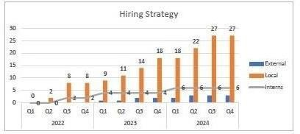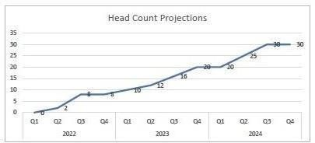

Figure 1

# 3.2.2 Innovations in Progress

Innovation in progress" in Athreya technologies refers to the ongoing development and implementation of new ideas, methods, processes, or products within an organization.

Figure 2

# 3.2.3 ORGANIZATION STRUCTURE

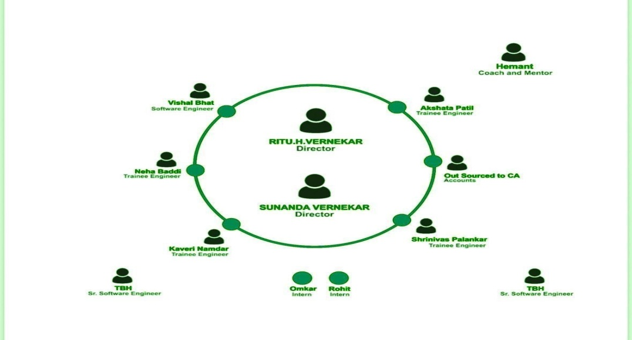Athreya Technologies believe in a lean organization structure.Lean organization for 2023/24 execution.

Figure 3

**3.2.4 PRODUCTS AND MARKET PERFORMANCE**

The Company are release the following products.

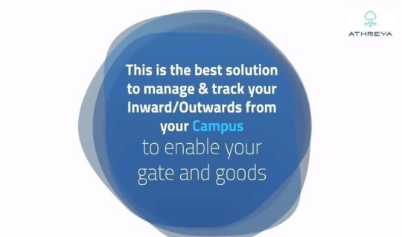**a Gate:** A simple solution for the inward and outward movement of goods for large campuses like manufacturing units, SEZs etc.

figure 4

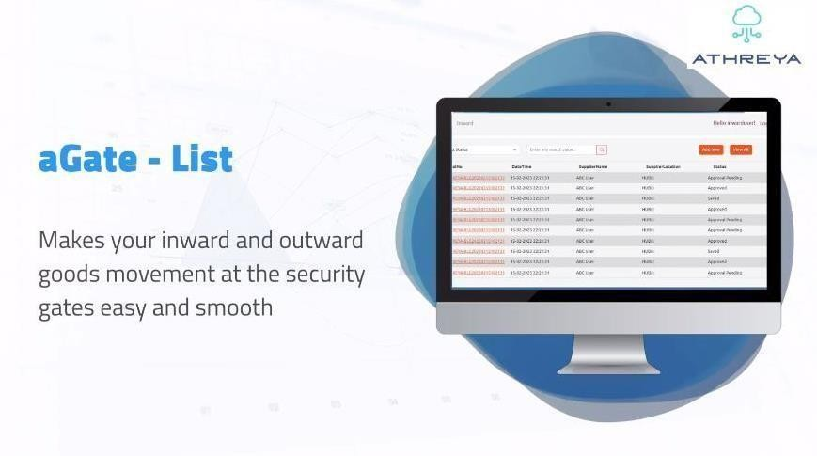figure 5

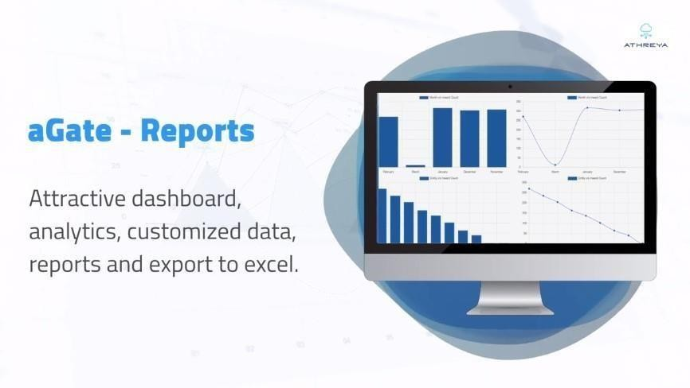

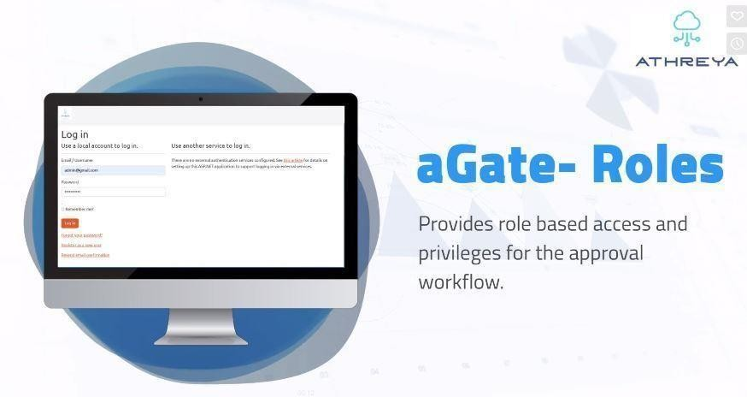figure 6

figure 7

# 3.2.5 Following are the innovative Products that are currently being developed.

* **Rootkits:** A simple tool to track employee’s activity in system is Rootkit. Itis a software which put on a computer. The Rootkit monitors the keystrokes on the operating system you are using, checking the paths each keystroke goesthrough. In this way, a Rootkit can keep track of your keystrokes and record each one
* **Incubator:** Solution to manage incubation centers and rental spaces for industrial campuses.
* **ICafe:** Patentable idea to make cafeterias intelligent and efficient apart fromthis team is in ideation state for two ideas that cannot be shared at this moment

**CHAPTER 4**

**HARDWARE AND SOFTWARE REQUIREMENTS**

**HARDWARE REQUIREMENTS**

Processor                                              Intel I3

RAM                                                  4GB

Hard Disk                                          20GB FREE SPACE

**SOFTWARE SPECIFICATIONS**

Operating System                               Windows 10 Above

Front End                                         HTML, CSS, Js

Backend JAVA .JSP

Database                                              My SQL

Web Server Tomcat

Design Tool Vs code

**CHAPTER 5**

**5.1SELECTED LANGUEGES**

**5.1.1HTML 4 AND HTML 5**

HTML 4 is a previous version of the HTML standard, which was widely used before the introduction of HTML5. When working with HTML 4 for a project, consider the following key aspects:

**Document Structure:** In HTML 4, use elements like <header>, <nav>, and <footer> sparingly or resort to traditional <div> elements for structural organization, as semantic elements were not available.

**Multimedia Handling:** To embed multimedia content, use <embed>, <object>, or third-party plugins (like Flash) since the native <video> and <audio> elements were not part of HTML 4.

**Graphics and Animations:** For creating graphics and animations, consider using technologies like GIF, Flash, or CSS animations, as the <canvas> element was not available in HTML 4.

**Forms:** Use <form> elements and traditional input types (e.g., <input type=”text”>, <input type=”checkbox”>, etc.) for form creation and validation.

**Offline Capabilities:** Offline support was limited in HTML 4, and developers often used cookies and server-side technologies for maintaining session data.

**Relocation and Real-time Communication:** HTML 4 did not provide built-in APIs for relocation or Web Sockets; developers had to rely on external scripts and plugins for such functionalities.

**Web Workers:** HTML 4 lacked the Web Workers API, making background processing and improved performance more challenging.

**Responsive Design:** Creating responsive designs in HTML 4 was possible but more cumbersome compared to HTML5’s dedicated features.

**Accessibility:** While accessibility practices were encouraged, HTML 4 lacked specific semantic elements to enhance accessibility as in HTML5.

HTML 4 was a significant step forward in web development, but it had limitations that HTML5 addressed. If you are working with HTML 4 for a project, consider the constraints it imposes and consider upgrading to HTML5 to leverage its enhanced features and capabilities for a more modern and robust web development experience.

**HTML5** (HyperText Markup Language 5) is the latest version of the standard markup language used to create and structure content on the web. It builds upon previous versions of HTML, introducing new elements, attributes, and APIs that enhance the capabilities of web development. Here’s a brief explanation of HTML5’s key features:

**Semantic Elements:** HTML5 introduced several semantic elements (e.g., <header>, <nav>, <main>, <footer>, etc.) that help define the structure and meaning of content, making it easier for search engines and screen readers to understand the page’s layout.

**Multimedia Support:** HTML5 provides native support for multimedia elements like <video> and <audio>, enabling developers to embed videos and audio content directly into web pages without relying on third-party plugins (like Flash).

**Canvas:** The <canvas> element allows developers to create dynamic and interactive graphics and animations directly within the browser, using JavaScript to manipulate the drawing context.

**Form Enhancements:** HTML5 introduced new input types (e.g., <email>, <url>, <date>, etc.) and attributes, making it easier to develop user-friendly and mobile-friendly forms with built-in validation.

**Offline Web Applications:** HTML5 introduced the Application Cache and Web Storage API, allowing web applications to store data locally and work offline, even without an active internet connection.

**Geolocation:** HTML5 provides a Geolocation API, enabling web applications to access the user’s location with permission, making it possible to create location-based services.

**WebSockets:** HTML5 introduced WebSockets, a communication protocol that enables real-time, bidirectional communication between the client and server, facilitating interactive and dynamic web applications.

**Web Workers:** HTML5 introduced Web Workers, which allow developers to run JavaScript code in the background, separate from the main thread, to improve performance and responsiveness in complex applications.

**Responsive Design:** HTML5 is instrumental in building responsive web designs that adapt to different screen sizes and devices, making web pages look great on both desktop and mobile devices.

**Improved Accessibility:** With the introduction of semantic elements and other accessibility features, HTML5 helps developers create more accessible web content for users with disabilities.

Overall, HTML5 provides a more powerful and flexible foundation for web development, enabling developers to create rich, interactive, and user-friendly web applications and websites.

**5.1.2 CSS**

**Introduction:** CSS is a style sheet language used to control the presentation and layout of HTML documents.

**Styling HTML Elements:** CSS allows you to apply styles to HTML elements, such as setting colors, fonts, margins, padding, and more.

**Selectors:** CSS selectors are used to target HTML elements and apply styles. Common selectors include element selectors, class selectors (.class-name), and ID selectors (#element-id).

**Box Model:** The CSS box model describes how elements are rendered on the web page, including content, padding, borders, and margins.

**Layout:** CSS provides various layout techniques, such as using floats, positioning (position: relative/absolute/fixed), and CSS Grid or Flexbox for more advanced layouts.

**Responsive Design:** CSS enables the creation of responsive web designs, ensuring the layout adapts to different screen sizes and devices.

**Media Queries:** Media queries in CSS allow you to apply specific styles based on the device’s characteristics, such as screen width, height, and orientation.

CSS Transitions and Animations: CSS supports transitions (transition) and keyframe animations (@keyframes) for adding smooth animations to elements.

**Pseudo-classes and Pseudo-elements:** CSS pseudo-classes (:hover, :active, etc.) and pseudo-elements (::before, ::after, etc.) allow you to target and style elements based on their state or position.

**CSS Preprocessors:** CSS preprocessors like Sass and Less extend CSS with variables, nesting, functions, and more, enhancing code maintainability.

**CSS Frameworks:** Popular CSS frameworks like Bootstrap and Foundation provide pre-designed CSS components and layout grids, speeding up web development.

**Vendor Prefixes:** Some CSS properties require vendor prefixes (e.g., -webkit-, -moz-, -ms-) for cross-browser compatibility with specific CSS features.

**Browser Compatibility:** Different web browsers may render CSS slightly differently, so it’s essential to test and ensure cross-browser compatibility.

**CSS Best Practices**: Following best practices, like using external CSS files, minification, and optimizing selectors, helps maintain a clean and efficient codebase.

**CSS-in-JS:** Modern approaches like CSS-in-JS allow styling components directly within JavaScript code, promoting component-based development.

CSS plays a critical role in web development, allowing developers to create visually appealing and consistent designs, ensuring a better user experience across different devices and browsers.

**5.1.3 JAVASCRIPT**

Introduction: JavaScript is a versatile and widely-used programming language primarily used for web development to add interactivity and dynamic behavior to web pages.

**Client-Side Scripting:** JavaScript is mainly executed in the user’s web browser, making it a client-side scripting language.

**Variables:** In JavaScript, you can declare variables using the var, let, or const keywords to store data.

**Data Types:** JavaScript has several data types, including numbers, strings, ooleans, objects, arrays, functions, etc.

**Operators:** JavaScript supports arithmetic, comparison, logical, assignment, and other operators for performing various operations.

**Control Flow:** JavaScript provides conditional statements (if, else if, else) and loops (for, while, do-while) for controlling the flow of the program.

**Functions:** Functions in JavaScript allow you to define reusable blocks of code that can be called with different arguments.

Event Handling: JavaScript is commonly used to handle events (e.g., button clicks, mouse movements) on web pages.

**DOM Manipulation:** JavaScript can interact with the Document Object Model (DOM) to dynamically modify HTML and CSS, allowing for interactive user interfaces.

**Asynchronous Programming:** JavaScript supports asynchronous operations using callbacks, Promises, and the async/await syntax, allowing for non-blocking operations.

**AJAX**: Asynchronous JavaScript and XML (AJAX) enable making server requests without reloading the entire web page.

**JSON:** JavaScript Object Notation (JSON) is a lightweight data interchange format widely used for data transfer between the server and web applications.

**Error Handling:** JavaScript provides mechanisms like try…catch to handle and manage errors during code execution.

**Modules:** With the introduction of ES6 (ECMAScript 2015), JavaScript supports modules, allowing code organization into reusable and separate files.

**Frameworks and Libraries:** JavaScript has numerous frameworks (e.g., React, Angular, Vue) and libraries (e.g., jQuery, Lodash) that streamline web development.

**Security:** Being executed on the client-side, JavaScript is susceptible to security vulnerabilities like cross-site scripting (XSS), which developers must be aware of and address.

**Compatibility:** JavaScript may be subject to browser compatibility issues, so it’s essential to test and ensure cross-browser compatibility.

JavaScript’s versatility, combined with its integration with HTML and CSS, makes it a crucial language for modern web development, enabling developers to build dynamic and interactive web applications.

**5.1.4 JSP**

JavaServer Pages (JSP) is a technology developed by Sun Microsystems (now owned by Oracle) to simplify the creation of dynamic web content. JSP is a part of the Java EE (Enterprise Edition) platform and allows developers to build web applications that can dynamically generate HTML, XML, or other types of documents in response to a web client’s request. Below is an overview of JSP, including its features, architecture, lifecycle, and advantages.

**5.1.5 MYSQL**

Structured Query Language (SQL) is the language used to manipulate relational databases. SQL is tied very closely with the relational model.

* In the relational model, data is stored in structures called relations or tables*.*

SQL statements are issued for the purpose of:

* Data definition: Defining tables and structures in the database (DDL used to create, alter and drop schema objects such as tables and indexes).

**List Of Sql Statements That Can Be Issued Against An Oracle Database Schema Are:**

1. ALTER – Change an existing table, view or index definition (DDL)
2. CREATE – Create new database objects such as tables or views (DDL)
3. DELETE- Delete rows from a database table (DML)
4. INSERT – Insert new data into a database table (DML)
5. ROLLBACK – Undo any recent changes to the database (DML – Transactional)
6. SELECT – Retrieve data from a database table (DML)
7. TRUNCATE – Delete all rows from a database table (can not be rolled back) (DML)
8. UPDATE- Change the values of some data items in a database table (DML)

**CHAPTER 6**

**SYSTEM DESIGN**

**ARCHITETURE DESIGN**

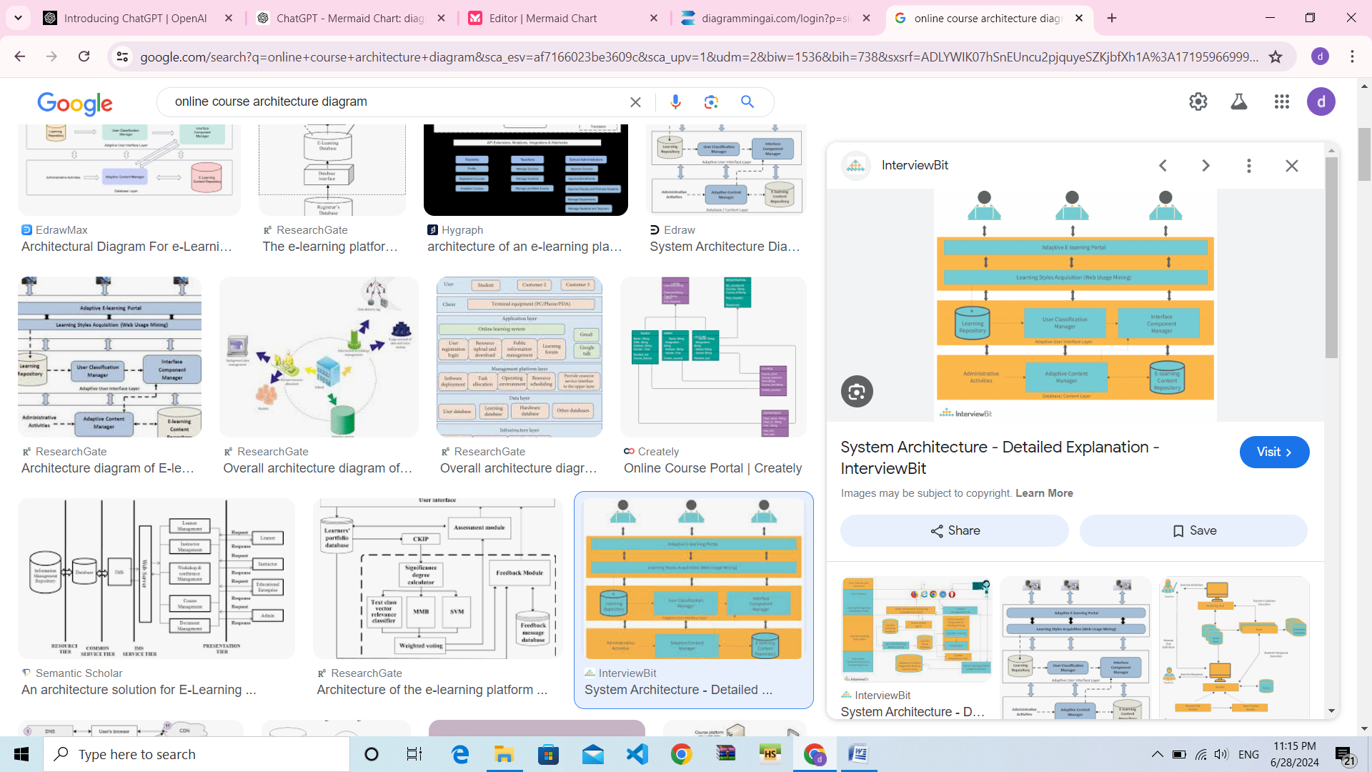

DFD diagram. A Data Flow Diagram (DFD) is a graphical representation of the flow of data through a system. It is used to model the processes involved in a system, as well as the data that is generated, processed, stored, and distributed by those processes.

**Purpose of DFD Diagrams:**

Data Flow Diagrams (DFDs) serve several critical purposes in system analysis and design. Firstly, they offer a clear depiction of the processes or functions occurring within a system, aiding in understanding its operational structure. By visualizing how data moves through various processes, DFDs help in identifying data sources and destinations, thus enabling a comprehensive grasp of data inputs and outputs. Moreover, these diagrams delineate system boundaries, distinguishing between internal processes and external entities. This clarity in delineation facilitates focused discussions on system functionalities among stakeholders. Additionally, DFDs act as a powerful communication tool, fostering understanding and consensus among system designers, stakeholders, and end-users.

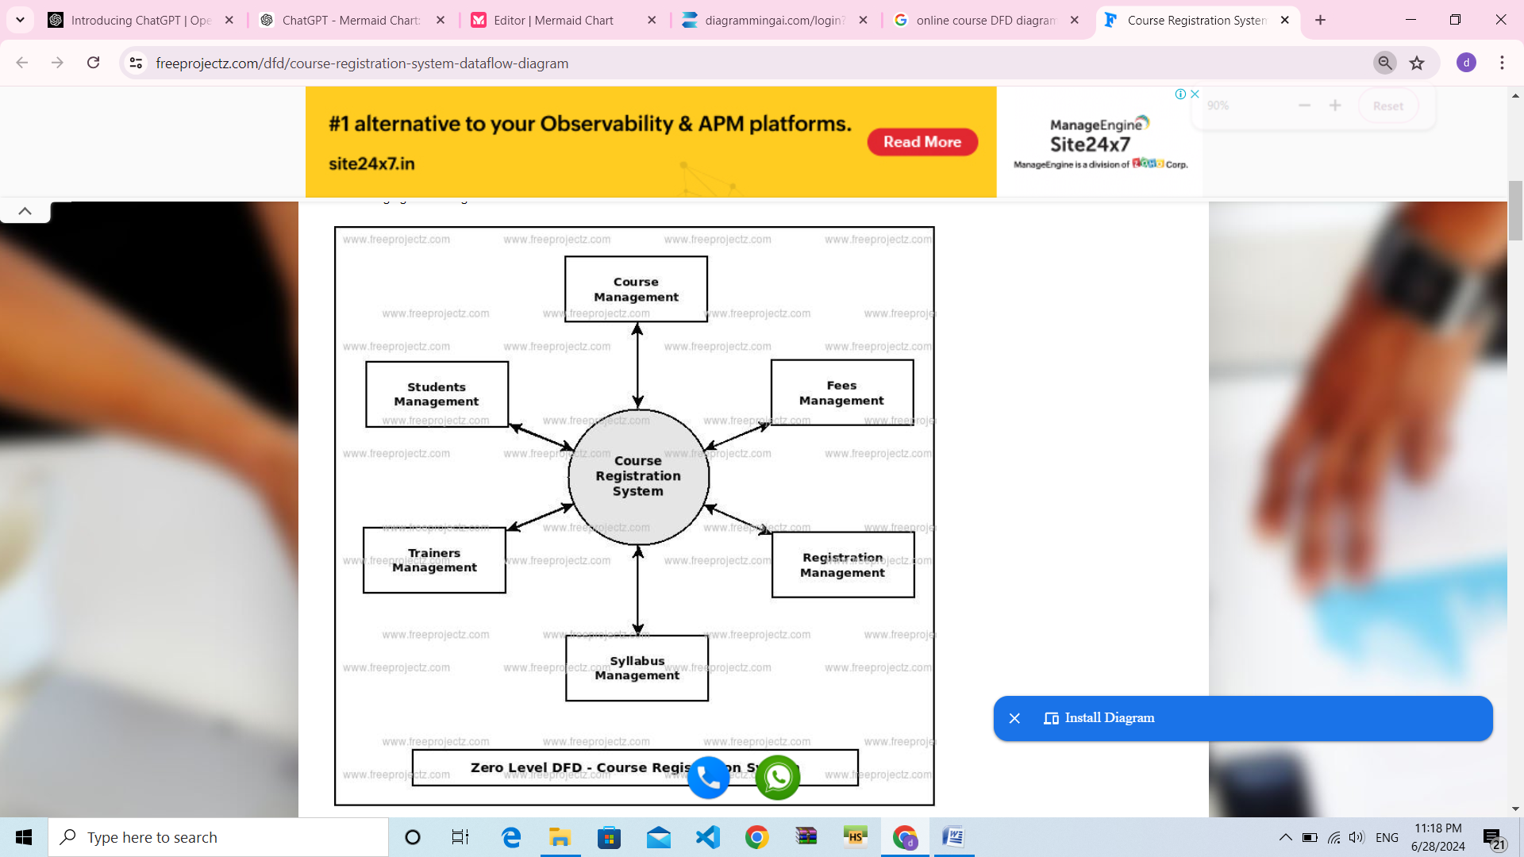

DFD LEVEL 1

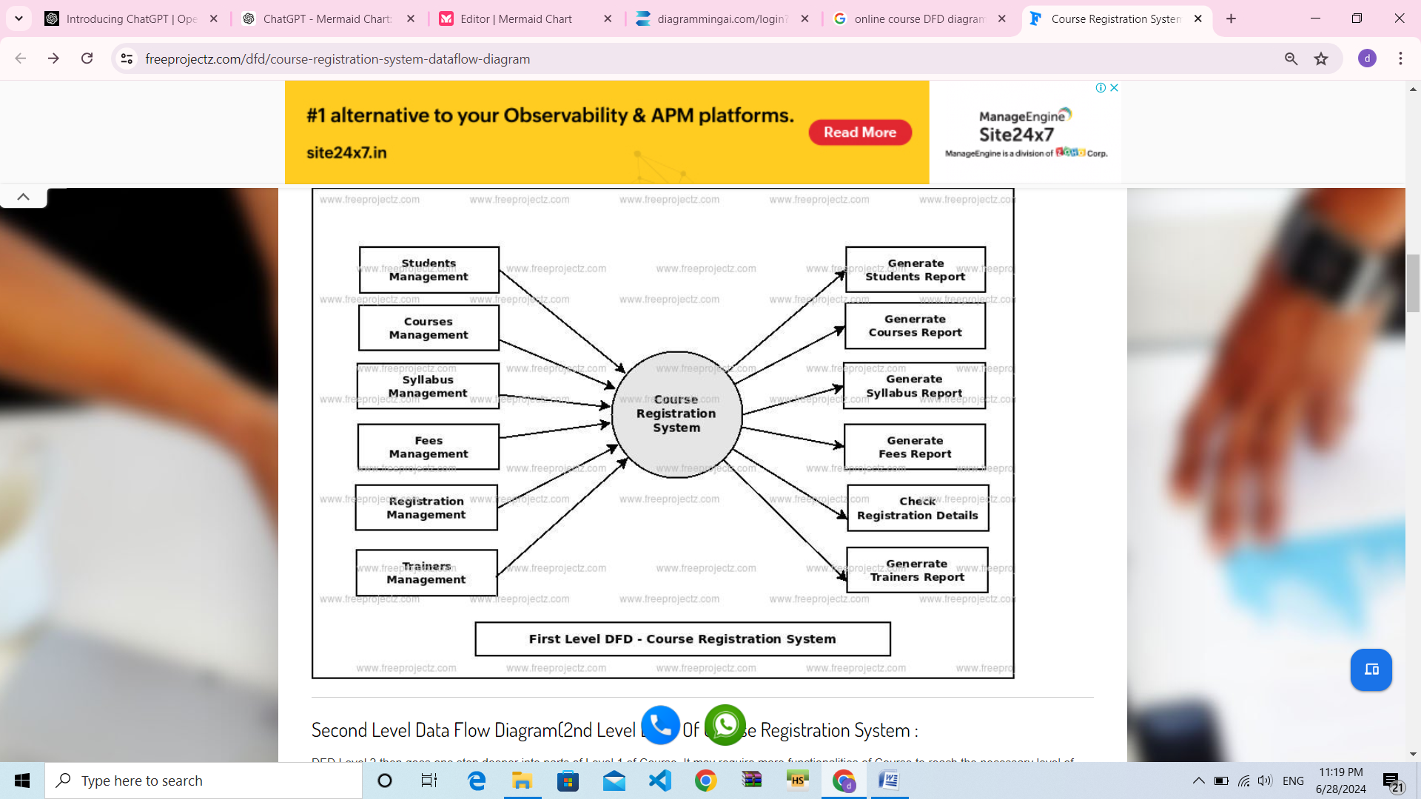

**Sequence diagram**:

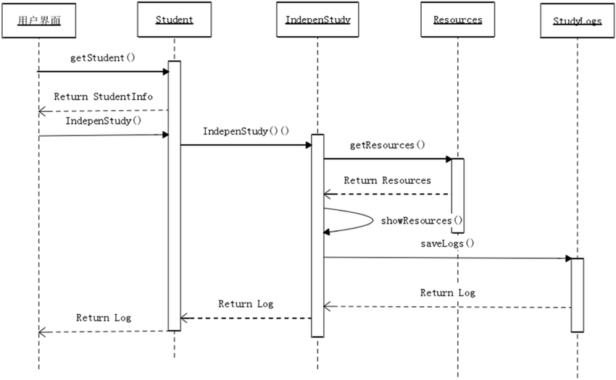A sequence diagram is a type of interaction diagram that illustrates the flow of messages and interactions between objects or components in a system. It is used to model the behavior of a system over time, and to visualize the interactions between different components or actors. Sequence diagrams consist of a vertical timeline, which represents the sequence of events or messages that occur between objects or components. Objects or components are represented by rectangles or other shapes along the timeline, and the interactions between them are represented by arrows or lines. Purpose of

**Class diagram.** A class diagram is a type of structural diagram in the Unified Modeling Language (UML) that illustrates the classes, interfaces, and relationships of a system. It is used to model the static structure of a system, including its attributes, methods, and relationships between objects.

**Activity diagram.** An activity diagram is a type of behavioral diagram in the Unified Modeling Language (UML) that illustrates the flow of activities or processes in a system. It is used to model the dynamic behavior of a system, including its processes, workflows, and interactions. Activity diagrams consist of a set of nodes that represent activities, decision points, and flows of control between the activities. Activities are represented as rounded rectangles with the activity name inside, and decision points are represented as diamonds with yes/no labels.

**Use case diagram**:

A use case diagram is a graphical representation of the interactions between actors (users or external systems) and a system. It is a high-level overview of the system's functionality and requirements. Use case diagrams are used to model the behavior of a system from a user's perspective, and to identify the different scenarios in which the system may be used. Use case diagrams typically include actors, use cases, and relationships between them. Actors are represented as stick figures, while use cases are represented as ovals.

The relationships between actors and use cases are represented as arrows. Use cases represent the various actions that the system can perform, such as "add a new user," "search for a product," or "place an order." Actors represent the different types of users or external systems that interact with the system, such as "customer," "administrator," or "payment gateway." Use case diagrams can be used to facilitate communication between stakeholders and development teams, and to help ensure that the system requirements are fully understood and properly implemented. They can also be used to identify potential issues and edge cases that may need to be addressed in the system design.

**Purpose of USE CASE Diagrams**:

The main purpose of a use case diagram is to portray the dynamic aspect of a system. It accumulates the system's requirement, which includes both internal as well as external influences. It invokes persons, use cases, and several things that invoke the actors and elements accountable for the implementation of use case diagrams. It represents how an entity from the external environment can interact with a part of the system.

**Following are the purposes of a use case diagram given below:**

1. It gathers the system's needs.

2. It depicts the external view of the system.

3. It recognizes the internal as well as external factors that influence the system.

4. It represents the interaction between the actors.

**Use case Diagram for Event Horizon:**

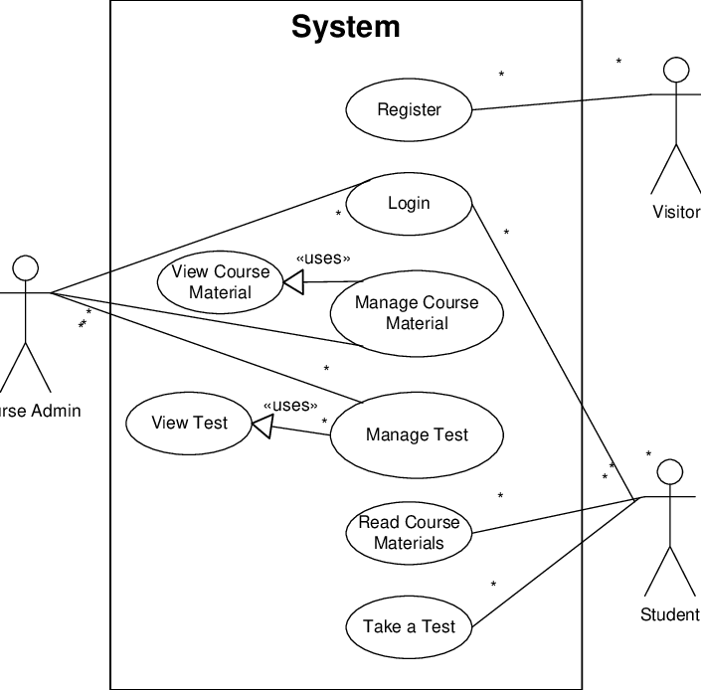**–**

**ER-DIAGRAM**

An entity-relationship diagram is a data modeling technique that creates a graphical representation of the entities, and the relationships between entities, within an information system. An **entity-relationship model** (**ERM**) is an abstract and conceptual representation of data. Entity-relationship modeling is a database modeling method, used to produce a type of conceptual schema or semantic data model of a system, often a relational database, and its requirements in a top-down fashion. Diagrams created by this process are called **entityrelationship diagrams**, **ER diagrams**, or **ERDs**.

**WEAK ENTITY:**



A weak entity is an entity that must defined by a foreign key relationship with another entity as it cannot be uniquely identified by its own attributes alone.

**ATTRIBUTE:**



Each entity has attributes or particular properties that describe the entity. Most of the data in a database consists of values of attributes. The set of all possible values of an attribute is the attribute domain. In an ER model, an attribute name appears in an oval that has a line to the corresponding entity box.

**KEY ATTRIBUTES:**

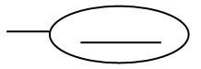

A key attribute is the unique, distinguishing characteristic of the entity. An attribute or set of attributes that uniquely identifies a particular entity is a key. A key attribute in an ER Diagram is represented by an oval that has a line inside it and a line to the corresponding entity box. For example, an employee’s social security number might be the employee’s key attribute.

**MULTI-VALUED ATTRIBUTE:**



A multi-valued attribute can have more than one value. We indicate this with a double oval. For example, an employee entity can have multiple skill values.

**DERIVED ATTRIBUTE:**



A derived attribute is based on another attribute. It is denoted by a oval and dotted line within it. For example, an employee’s monthly salary is based on the employee’s annual salary.

**RELATIONSHIPS:**



Relationships illustrate how two entities share information in the database structure. An association among entities is called a relationship. An attribute can also be a property of a relationship set. The association among the entities is described as one-to-one, one-to-many, many-to-many. A relationship is indicated by a rhombus.

**IDENTIFYING RELATIONSHIP:**



Identifying relationship is denoted by double rhombus.

#### COMPOSITE ATTRIBUTE

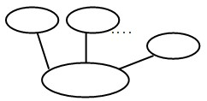

A composite attribute has multiple components and each component is atomic or composite. We illustrate this composite nature in the ER model by branching off the component attributes.

**TOTAL PARTICIPATION:**

**CHAPTER 7**

**IMPLAMENTATION CODE**

<!DOCTYPE html>

<html lang="en">

<head>

<!-- Meta -->

<meta charset="UTF-8">

<meta name="viewport" content="width=device-width, initial-scale=1.0">

<title>PAP</title>

<!--bootsrap styles sheet-->

<link rel="stylesheet" href="https://stackpath.bootstrapcdn.com/bootstrap/4.5.2/css/bootstrap.min.css"

integrity="sha384-JcKb8q3iqJ61gNV9KGb8thSsNjpSL0n8PARn9HuZOnIxN0hoP+VmmDGMN5t9UJ0Z" crossorigin="anonymous">

<link href="https://cdn.jsdelivr.net/npm/bootstrap@5.3.2/dist/css/bootstrap.min.css" rel="stylesheet" integrity="sha384-T3c6CoIi6uLrA9TneNEoa7RxnatzjcDSCmG1MXxSR1GAsXEV/Dwwykc2MPK8M2HN" crossorigin="anonymous">

<!-- style sheet for complete website -->

<link rel="stylesheet" href="Assets/css/html.css">

<!-- font family Montserrat and roboto slab -->

<link

href="https://fonts.googleapis.com/css2?family=Montserrat:ital,wght@0,300;0,400;0,500;0,600;0,700;0,800;1,300;1,400&family=Roboto+Slab:wght@200;300;400;500;600;700;800&display=swap"

rel="stylesheet">

<!-- font awesome icon link -->

<script src="https://kit.fontawesome.com/ca30ddfff9.js" crossorigin="anonymous"></script>

</head>

<body>

<div class="collapse" id="navbarToggleExternalContent">

<div class="bg-dark p-4">

<nav class="navbar navbar-expand-lg navbar-light bg-light">

<div class="container-fluid">

<a class="navbar-brand" href="index.html">Home</a>

<button class="navbar-toggler" type="button" data-bs-toggle="collapse" data-bs-target="#navbarNav" aria-controls="navbarNav" aria-expanded="false" aria-label="Toggle navigation">

<span class="navbar-toggler-icon"></span>

</button>

<div class="collapse navbar-collapse" id="navbarNav">

<ul class="navbar-nav">

<li class="nav-item">

<a class="nav-link" href="login.html">Login</a>

</li>

<li class="nav-item">

<a class="nav-link" href="html/blog.html">Blog</a>

</li>

<li class="nav-item">

<a class="nav-link" href="html/product.html">Products</a>

</li>

<li class="nav-item">

<a class="nav-link" href="#">Contact</a>

</li>

&nbsp;&nbsp;&nbsp;&nbsp;&nbsp;&nbsp;&nbsp;&nbsp;&nbsp;&nbsp;&nbsp;<div class="collapse navbar-collapse" id="navbarNavDarkDropdown">

&

<ul class="navbar-nav">

<li class="nav-item dropdown">

<button class="btn btn-dark dropdown-toggle" data-bs-toggle="dropdown" aria-expanded="false">

Views

</button>

<ul class="dropdown-menu dropdown-menu-dark">

<li><a class="dropdown-item" href="Accessories.html">Accessories</a></li>

<li><a class="dropdown-item" href="product table.html">Product_Details</a></li>

<li><a class="dropdown-item" href="Rate chart.html">Rate_Chart</a></li>

<li><a class="dropdown-item" href="service.html">Service_Details</a></li>

</ul>

</li>

</ul>

</div>

</div>

</ul>

</div>

</div>

</nav>

</div>

</div>

<nav class="navbar navbar-dark bg-dark">

<div class="container-fluid">

<button class="navbar-toggler" type="button" data-bs-toggle="collapse" data-bs-target="#navbarToggleExternalContent" aria-controls="navbarToggleExternalContent" aria-expanded="false" aria-label="Toggle navigation">

<span class="navbar-toggler-icon"></span>

</button>

</div>

</nav>

</nav>

<!-- second navbar shows all the categories for auto parts-->

<nav class="category-navbar d-none d-lg-inline d-md-inline d-sm-none ">

<ul

class="d-flex justify-content-around align-items-center list-unstyled mx-5 my-3 my-lg-0 my-md-0 my-sm-3 py-2 rounded-pill font-weight-bold">

<li class="dropdown">

<span class="font-weight-bolder text-white">SHOP BY CATEGORY:</span>

</li>

<li class="dropdown">

<!-- first category -->

<a class="dropdown-toggle text-decoration-none text-white" id="dropdownMenuButton"

data-toggle="dropdown" aria-haspopup="true" aria-expanded="false" href="#">Tyre and Wheels</a>

<div class="dropdown-menu" aria-labelledby="dropdownMenuButton">

<a class="dropdown-item" href="wheels.html">Wheel Accessories <span

class="category-arrow"><i class="fas fa-chevron-right"></i></span> </a>

<a class="dropdown-item" href="nutsproduct.html.html">Nuts <span

class="category-arrow"><i class="fas fa-chevron-right"></i></span> </a>

<a class="dropdown-item" href="tyres.html">Tyres <span

class="category-arrow"><i class="fas fa-chevron-right"></i></span> </a>

</div>

</li>

<li class=" dropdown ">

<!-- Second category -->

<a class="dropdown-toggle text-decoration-none text-white" id="dropdownMenuButton"

data-toggle="dropdown" aria-haspopup="true" aria-expanded="false" href="#">Exterior</a>

<div class="dropdown-menu" aria-labelledby="dropdownMenuButton">

<a class="dropdown-item" href="window visor.html">Window Visors <span

class="category-arrow"><i class="fas fa-chevron-right"></i></span> </a>

<a class="dropdown-item" href="door,locks,accessories.html">Door Handles, Locks & Accessories

<span class="category-arrow"><i class="fas fa-chevron-right"></i></span> </a>

<a class="dropdown-item" href="Truck accessories.html">Truck Accessories <span

class="category-arrow"><i class="fas fa-chevron-right"></i></span> </a>

</div>

</li>

<li class=" dropdown ">

<!-- 3rd category -->

<a class="dropdown-toggle text-decoration-none text-white" id="dropdownMenuButton"

data-toggle="dropdown" aria-haspopup="true" aria-expanded="false" href="#"> Interior</a>

<div class="dropdown-menu" aria-labelledby="dropdownMenuButton">

<a class="dropdown-item" href="Horn and components.html">Horns and Components <span

class="category-arrow"><i class="fas fa-chevron-right"></i></span> </a>

<a class="dropdown-item" href="Switches,relay&wire components.html">Switches, Relays and Wiring

Components <span class=" "><i class="fas fa-chevron-right"></i></span> </a>

</div>

</li>

<li class=" dropdown ">

<!-- fourth category -->

<a class="dropdown-toggle text-decoration-none text-white" id="dropdownMenuButton"

data-toggle="dropdown" aria-haspopup="true" aria-expanded="false" href="#">Car Parts</a>

<div class="dropdown-menu" aria-labelledby="dropdownMenuButton">

<a class="dropdown-item" href="back&headlight.html">Back & Head Lights <span

class="category-arrow"><i class="fas fa-chevron-right"></i></span> </a>

</div>

</li>

</ul>

</nav>

</header>

<!-- slider -->

<main class="mb-5">

<section class="slider position-relative d-flex justify-content-end align-items-center py-5 mt-4">

<!-- section created to give a colored background to the slider section -->

<section class="position-absolute corousel-bg"></section>

<div id="carouselExampleSlidesOnly" class="carousel slide w-50" data-ride="carousel">

<div class="carousel-inner">

<div class="carousel-item active" data-interval="2500">

<img src="Assets/images/website-images/slider-1.webp" class="d-block w-75 mx-auto" alt="...">

<h3 class="w-75 mx-auto">High Quality Products</h3>

</div>

<div class="carousel-item" data-interval="2500">

<img src="Assets/images/website-images/slider-2.webp" class="d-block w-75 mx-auto" alt="...">

<h3 class="w-75 mx-auto">Premium Products</h3>

</div>

<div class="carousel-item" data-interval="2500">

<img src="Assets/images/website-images/slider-3.webp" class="d-block w-75 mx-auto" alt="...">

<h3 class="w-75 mx-auto">Cheaper Rate</h3>

</div>

</div>

</div>

<div>

<h1 class="usp ml-lg-5 ml-md-4 text-center position-absolute w-50 text-uppercase"> Buy

Accessories</h1>

</div>

</section>

<!--Slider -->

<!-- About Decent Auto Parts -->

<section class="about w-75 mx-auto my-5" id="about-us">

<h1 class="text-uppercase">About Us</h1>

<div class="d-flex justify-content-around align-items-center ">

<p class="w-100 w-sm-100 w-md-75 w-lg-50 mr-lg-5 mr-md-5 text-justify">

At Decent Auto Parts we offer an extensive selection of auto parts, truck parts and automotive

accessories, so you can easily find the quality parts you need at the lowest price. Explore our wide

inventory to find both brand new car parts and

second-hand

parts for your vehicle. We are one of the largest distributors of auto parts online in Bangladesh.

Our customers have come to know us as the best place to

buy auto parts online.

</p>

<span class="d-none d-sm-none d-md-flex d-lg-flex"> <img src="Assets/images/website-images/about.png"

alt="wheel image" width="300em"></span>

</div>

</section>

<!-- Categories Section-->

<section class="category-sec mx-auto pt-5" id="shop-by-category">

<h1 class="text-center text-uppercase">Categories</h1>

<section class="all-category mb-5">

<!-- category 1-->

<div class="pt-2 pb-5 px-5" id="1">

<div class="lg-w-75 mx-auto">

<h2 class="mt-4 font-weight-bold">Wheels</h2>

<div class="d-flex justify-content-around flex-wrap align-items-center">

<!-- 1st Sub Category -->

<div class="card my-3 my-lg-0 my-md-0 my-sm-3" style="width: 18rem;">

<img src="Assets/images/website-images/wheel-accessories.jpg"

class=" card-img-top w-50 mx-auto img-fluid pt-2 pb-1" alt="wheel accessories"

id="zoom-img">

<div class="card-body">

<h6 class="card-title">Wheel Accessories</h6>

<p class="card-text">Variety of Wheel Accessories</p>

<a href="wheels.html" class="btn">View <span class="ml-3"><i

class="fas fa-chevron-right"></i></span></a>

</div>

</div>

<!-- 2nd Sub Category -->

<div class="card my-3 my-lg-0 my-md-0 my-sm-3" style="width: 18rem;">

<img src="Assets/images/website-images/nuts.png"

class="card-img-top w-50 mx-auto pt-4 img-fluid" alt="nuts" id="zoom-img">

<div class="card-body">

<h6 class="card-title">Nuts</h6>

<p class="card-text"> Variety of Nuts</p>

<a href="nutsproduct.html.html" class="btn">View <span class="ml-3"><i

class="fas fa-chevron-right"></i></span></a>

</div>

</div>

<!-- 3rd Sub Category -->

<div class="card my-3 my-lg-0 my-md-0 my-sm-3 overflow-hidden" style="width: 18rem;">

<img src="Assets/images/website-images/tyre.png"

class="card-img-top w-50 mx-auto img-fluid" alt="tyre" id="zoom-img">

<div class="card-body">

<h6 class="card-title">Tyres</h6>

<p class="card-text pb-2">Variety of Tyre Accessories

</p>

<a href="tyres.html" class="btn">View <span class="ml-3"><i

class="fas fa-chevron-right"></i></span></a>

</div>

</div>

</div>

</div>

</div>

<!-- category 2-->

<div class="pt-2 pb-5 px-5" id="2">

<div class="lg-w-75 mx-auto">

<h2 class="mt-4 font-weight-bold">External Parts</h2>

<div class="d-flex justify-content-around flex-wrap align-items-center">

<!-- 1st Sub Category -->

<div class="card my-3 my-lg-0 my-md-0 my-sm-3 pt-3" style="width: 18rem;">

<img src="Assets/images/website-images/window-visors.png"

class="card-img-top w-75 mx-auto" alt="window visor" id="zoom-img">

<div class="card-body">

<h6 class="card-title">Window Visors</h6>

<p class="card-text">Variety of Window Visor Accessories.</p>

<a href="window visor.html" class="btn">View <span class="ml-3"><i

class="fas fa-chevron-right"></i></span></a>

</div>

</div>

<!-- 2nd Sub Category -->

<div class="card my-3 my-lg-0 my-md-0 my-sm-3 pt-5" style="width: 18.3rem;">

<img src="Assets/images/website-images/door-accessories.png"

class="card-img-top w-50 mx-auto" alt="door accessories" id="zoom-img">

<div class="card-body">

<h6 class="card-title">Door Handles, Locks & Accessories</h6>

<p class="card-text">Various Door Handles, Locks & Accessories

</p>

<a href="door,locks,accessories.html" class="btn">View <span class="ml-3"><i

class="fas fa-chevron-right"></i></span></a>

</div>

</div>

<!-- 3rd Sub Category -->

<div class="card my-3 my-lg-0 my-md-0 my-sm-3 pt-5" style="width: 17.5rem;">

<img src="Assets/images/website-images/truck-accessories.png"

class="card-img-top w-50 mx-auto pt-2" alt="truck-accessories" id="zoom-img">

<div class="card-body">

<h6 class="card-title">Truck Accessories</h6>

<p class="card-text">Variety of Truck Accessories</p>

<a href="Truck accessories.html" class="btn">View <span class="ml-3"><i

class="fas fa-chevron-right"></i></span></a>

</div>

</div>

</div>

</div>

</div>

<!-- category 3-->

<div class="pt-2 pb-5 px-5" id="3">

<div class="lg-w-75 mx-auto">

<h2 class="mt-4 font-weight-bold">Internal Parts</h2>

<div class="d-flex justify-content-around flex-wrap align-items-center">

<!-- 1st Sub Category -->

<div class="card my-3 my-lg-0 my-md-0 my-sm-3 pt-4" style="width: 18rem;">

<img src="Assets/images/website-images/mobile-electronics.png"

class="card-img-top w-75 mx-auto" alt="mobile electronics" id="zoom-img">

</div>

<!-- 2nd Sub Category -->

<div class="card my-3 my-lg-0 my-md-0 my-sm-3 pt-1 overflow-hidden" style="width: 18rem;">

<img src="Assets/images/website-images/car-horn.png" class="card-img-top w-75 mx-auto"

alt="car horn" id="zoom-img">

<div class="card-body">

<h6 class="card-title">Horns and Components</h6>

<p class="card-text">Variety of Horns and Components</p>

<a href="Horn and components.html" class="btn">View <span class="ml-3"><i

class="fas fa-chevron-right"></i></span></a>

</div>

</div>

<!-- 3rd Sub Category -->

<div class="card my-3 my-lg-0 my-md-0 my-sm-3 pt-4 pb-1" style="width: 18rem;">

<img src="Assets/images/website-images/car-relay.png" class="card-img-top w-50 mx-auto"

alt="car relay switch" id="zoom-img">

<div class="card-body">

<h6 class="card-title">Switches, Relays, Wiring Components </h6>

<p class="card-text">Variety of Switches, Relays, Wiring Components</p>

<a href="Switches,relay&wire components.html" class="btn">View <span class="ml-3"><i

class="fas fa-chevron-right"></i></span></a>

</div>

</div>

</div>

</div>

</div>

<!--category 4-->

<div class="pt-2 pb-5 px-5 " id="4">

<div class="lg-w-75 mx-auto">

<h2 class="mt-4 font-weight-bold">Car Parts</h2>

<div class="d-flex justify-content-around flex-wrap align-items-center">

<!-- 1st Sub Category -->

<div class="card my-3 my-lg-0 my-md-0 my-sm-3 overflow-hidden" style="width: 18rem;">

<img src="Assets/images/website-images/car-headlight.png"

class="card-img-top w-75 mx-auto" alt="car headlight" id="zoom-img">

<div class="card-body">

<h6 class="card-title">Back & Head Lights</h6>

<p class="card-text">Variety of Back & Head Lights Accessories</p>

<a href="back&headlight.html" class="btn">View <span class="ml-3"><i

class="fas fa-chevron-right"></i></span></a>

</div>

</div>

<!-- 2nd Sub Category -->

<div class="card my-3 my-lg-0 my-md-0 my-sm-3 overflow-hidden" style="width: 18rem;">

<img src="Assets/images/website-images/side-mirrors.png" class="card-img-top w-75"

alt="side mirror" id="zoom-img">

<div class="card-body">

<h6 class="card-title">Side Mirrors</h6>

<p class="card-text">Variety of Side Mirror Accessories</p>

<a href="html/product.html?id=4&c_id=2" class="btn">View <span class="ml-3"><i

class="fas fa-chevron-right"></i></span></a>

</div>

</div>

<!-- 3rd Sub Category -->

<div class="card my-3 my-lg-0 my-md-0 my-sm-3 pt-2 overflow-hidden" style="width: 18rem;">

<img src="Assets/images/website-images/wiper-blades.png" class="card-img-top mx-auto"

alt="wiper blades" id="zoom-img">

<div class="card-body">

<h6 class="card-title">Wiper Blades</h6>

<p class="card-text">Variety of different Wiper Blades Accessories

</p>

<a href="html/product.html?id=4&c_id=3" class="btn mt-1">View <span class="ml-3"><i

class="fas fa-chevron-right"></i></span></a>

</div>

</div>

</div>

</div>

</div>

</section>

</section>

</main>

<!-- footer columns-->

<footer>

<section class="pb-3 footer-section">

<section class="mt-0 d-flex container justify-content-between align-items-top flex-wrap">

<div id="contact-us">

<!-- 1st column -->

<ul class="container list-unstyled">

<li>

<h6 class="font-weight-bold">Contact Us</h6>

</li>

<li>

<!-- icon -->

<span><svg xmlns="http://www.w3.org/2000/svg" x="0px" y="0px" width="15" height="15"

viewBox="0 0 172 172" style=" fill:#000000;">

<g fill="none" fill-rule="nonzero" stroke="none" stroke-width="1"

stroke-linecap="butt" stroke-linejoin="miter" stroke-miterlimit="10"

stroke-dasharray="" stroke-dashoffset="0" font-family="none" font-weight="none"

font-size="none" text-anchor="none" style="mix-blend-mode: normal">

<path d="M0,172v-172h172v172z" fill="none"></path>

<g fill="#ffffff">

<path

d="M86,14.33333c-11.87517,0 -21.5,9.62483 -21.5,21.5c0,11.87517 9.62483,21.5 21.5,21.5c11.87517,0 21.5,-9.62483 21.5,-21.5c0,-11.87517 -9.62483,-21.5 -21.5,-21.5zM64.5,71.66667c-2.58456,-0.03655 -4.98858,1.32136 -6.29153,3.55376c-1.30295,2.2324 -1.30295,4.99342 0,7.22582c1.30295,2.2324 3.70697,3.59031 6.29153,3.55376h7.16667v57.33333h-7.16667c-2.58456,-0.03655 -4.98858,1.32136 -6.29153,3.55376c-1.30295,2.2324 -1.30295,4.99342 0,7.22582c1.30295,2.2324 3.70697,3.59031 6.29153,3.55376h43c2.58456,0.03655 4.98858,-1.32136 6.29153,-3.55376c1.30295,-2.2324 1.30295,-4.99342 0,-7.22582c-1.30295,-2.2324 -3.70697,-3.59031 -6.29153,-3.55376h-7.16667v-64.5c0,-3.956 -3.21067,-7.16667 -7.16667,-7.16667h-14.33333z">

</path>

</g>

</g>

</svg></span>

<!-- about us contains an anchor link that directs the user to the about us section -->

<a href="#about-us" class="text-decoration-none"> About</a>

</li>

<!-- address -->

<li><span><i class="fas fa-map-marker-alt"></i></span> Address: <br> Dholaikhal, Shop No. 31

</li>

<!-- phone number -->

<li><span><i class="fas fa-phone-alt"></i></span> Phone No: <br> +8801*****</li>

<!-- email address -->

<li><span><i class="fas fa-envelope"></i></span> Email: <address class="mb-0"><a

href="mailto:project@gmail.com" class="text-decoration-none">project@gmail.com</a>

</address>

</li>

<!-- facebook -->

<li><span>Facebook Page: <br><i class="fab fa-facebook-f"></i></span><a

href="https://www.facebook.com/project" class="text-decoration-none">

Facebook</a>

</ul>

</div>

<!-- Categories column -->

<div>

<ul class="list-unstyled container">

<li>

<h6 class="font-weight-bold">Categories</h6>

</li>

<li><span></span><a href="index.html class="text-decoration-none">Tyres and Wheels</a></li>

<li><span></span><a href="index.html" class="text-decoration-none">External Parts</a></li>

<li><span></span><a href="index.html" class="text-decoration-none">Interior</a></li>

<li><span></span><a href="in" class="text-decoration-none">Accessories</a></li>

</ul>

</div>

<div>

<!-- 1st ul -->

<ul class="list-unstyled container">

<li>

<!-- icon -->

<span><svg xmlns="http://www.w3.org/2000/svg" x="0px" y="0px" width="30" height="30"

viewBox="0 0 172 172" style=" fill:#000000;">

<g fill="none" fill-rule="nonzero" stroke="none" stroke-width="1"

stroke-linecap="butt" stroke-linejoin="miter" stroke-miterlimit="10"

stroke-dasharray="" stroke-dashoffset="0" font-family="none" font-weight="none"

font-size="none" text-anchor="none" style="mix-blend-mode: normal">

<path d="M0,172v-172h172v172z" fill="none"></path>

<g fill="#ffffff">

<path

</g>

</g>

</svg></span>

<h6 class="d-inline font-weight-bold">Great Discounts!</h6>

</li>

<li>

<p>Exclusive Products</p>

</li>

<li>

<p>Authentic products</p>

</li>

<li>

<p>Quick Delivery</p>

</li>

</ul>

<!-- 2nd ul -->

<ul class="list-unstyled container">

<li>

<!-- icon -->

<span><svg xmlns="http://www.w3.org/2000/svg" x="0px" y="0px" width="24" height="24"

viewBox="0 0 172 172" style=" fill:#000000;">

<g fill="none" fill-rule="nonzero" stroke="none" stroke-width="1"

stroke-linecap="butt" stroke-linejoin="miter" stroke-miterlimit="10"

stroke-dasharray="" stroke-dashoffset="0" font-family="none" font-weight="none"

font-size="none" text-anchor="none" style="mix-blend-mode: normal">

<path d="M0,172v-172h172v172z" fill="none"></path>

<g fill="#ffffff">

<path

</path>

</g>

</g>

</svg></span>

<h6 class="d-inline font-weight-bold">Easy Online Shopping</h6>

</li>

<li>

<p>Get all Your auto parts</p>

</li>

<li>

<p>Full Customer Support</p>

</li>

<li>

<p>Cash on Delivery</p>

</li>

</ul>

</div>

</section>

</section>

<!-- copyright section -->

<div class="w-100 copyright-section">

<small class="ml-5">

&copy Copyright 2021

</small>

</div>

</footer>

<!-- scripting files -->

<script src="https://cdn.jsdelivr.net/npm/bootstrap@5.3.2/dist/js/bootstrap.bundle.min.js" integrity="sha384-C6RzsynM9kWDrMNeT87bh95OGNyZPhcTNXj1NW7RuBCsyN/o0jlpcV8Qyq46cDfL" crossorigin="anonymous"></script>

<!-- sweet alert scripting -->

<script src="https://unpkg.com/sweetalert/dist/sweetalert.min.js"></script>

<!-- external index js files -->

<script src="assets/script/index.js"></script>

<script src="https://code.jquery.com/jquery-3.5.1.slim.min.js"

integrity="sha384-DfXdz2htPH0lsSSs5nCTpuj/zy4C+OGpamoFVy38MVBnE+IbbVYUew+OrCXaRkfj"

crossorigin="anonymous"></script>

<script src="https://cdn.jsdelivr.net/npm/popper.js@1.16.1/dist/umd/popper.min.js"

integrity="sha384-9/reFTGAW83EW2RDu2S0VKaIzap3H66lZH81PoYlFhbGU+6BZp6G7niu735Sk7lN"

crossorigin="anonymous"></script>

<script src="https://stackpath.bootstrapcdn.com/bootstrap/4.5.2/js/bootstrap.min.js"

integrity="sha384-B4gt1jrGC7Jh4AgTPSdUtOBvfO8shuf57BaghqFfPlYxofvL8/KUEfYiJOMMV+rV"

crossorigin="anonymous"></script>

</body>

</html>

**CHAPTER 8**

**OUTPUT SCREENSHOT**

**CHAPTER 9**

**TESTING**

The philosophy behind testing is to find bugs. The common view of testing Is that there are no errors in a program. However it is virtually impossible to prove that no program will be free and clear of errors [11]. Therefore the most useful approach and practical approach is with the understanding that testing is the program fail.

Executing a program in a simulated environment performs verification. It is sometimes called Alpha Testing. Validation is the process of using the software in a live environment in order to find errors. It can be called as Beta Testing.

System testing is the stage of implementation, which aims at ensuring that the system works accurately and efficiently before actual operation commences.

No program or system design is perfect; communication between the user and the designer is not always complete or clear, and time is usually short. The result is errors and more errors. The number and nature of errors in a design depend on several factors:

1. Communication between the user and the designer.
2. The programmer’s ability to generate a code that reflects exactly
3. The system specification.
4. The time frame for the design.

**TYPES OF TESTING:**

**UNIT TESTING**

Unit testing involves the design of test cases that validate that the internal program logic is functioning properly, and that program input produces valid outputs. All decision branches and internal code flow should be validated. It is the testing of individual software units of the application .it is done after the completion of an individual unit before integration. This is a structural testing, that relies on knowledge of its construction and is invasive. Unit tests perform basic tests at component level and test a specific business process, application, and/or system configuration. Unit tests ensure that each unique path of a business process performs accurately to the documented specifications and contains clearly defined inputs and expected results.

**INTEGRATION TESTING**

Integration tests are designed to test integrated software components to determine if they actually run as one program. Testing is event driven and is more concerned with the basic outcome of screens or fields. Integration tests demonstrate that although the components were individually satisfaction, as shown by successfully unit testing, the combination of components is correct and consistent. Integration testing is specifically aimed at exposing the problems that arise from the combination of components.

**FUNCTIONAL TEST**

Functional tests provide a systematic demonstration that functions tested are available as specified by the business and technical requirements, system documentation, and user manuals.

Functional testing is centered on the following items:

Valid Input : identified classes of valid input must be accepted.

Invalid Input : identified classes of invalid input must be rejected.

Functions : identified functions must be exercised.

Output : identified classes of application outputs must be exercised.

Systems/Procedures : interfacing systems or procedures must be invoked.

Organization and preparation of functional tests is focused on requirements, key functions, or special test cases. In addition, systematic coverage pertaining to identify

Business process flows; data fields, predefined processes, and successive processes must be considered for testing. Before functional testing is complete, additional tests are identified and the effective value of current tests is determined.

**SYSTEM TEST**

System testing ensures that the entire integrated software system meets requirements. It tests a configuration to ensure known and predictable results. An example of system testing is the configuration oriented system integration test. System testing is based on process descriptions and flows, emphasizing pre-driven process links and integration points.

**WHITE BOX TESTING**

White Box Testing is a testing in which in which the software tester has knowledge of the inner workings, structure and language of the software, or at least its purpose. It is purpose. It is used to test areas that cannot be reached from a black box level.

**BLACK BOX TESTING**

Black Box Testing is testing the software without any knowledge of the inner workings, structure or language of the module being tested. Black box tests, as most other kinds of tests, must be written from a definitive source document, such as specification or requirements document, such as specification or requirements document.

It is a testing in which the software under test is treated, as a black box .you cannot “see” into it. The test provides inputs and responds to outputs without considering how the software works

**UNIT TESTING:**

Unit testing is usually conducted as part of a combined code and unit test phase of the software lifecycle, although it is not uncommon for coding and unit testing to be conducted as two distinct phases.

**Test strategy and approach**

Field testing will be performed manually and functional tests will be written in detail.

**Test objectives**

* All field entries must work properly.
* Pages must be activated from the identified link.
* The entry screen, messages and responses must not be delayed.

**Features to be tested**

* Verify that the entries are of the correct format
* No duplicate entries should be allowed
* All links should take the user to the correct page.

# INTEGRATION TESTING

# Software integration testing is the incremental integration testing of two or more integrated software components on a single platform to produce failures caused by interface defects.

# The task of the integration test is to check that components or software applications, e.g. components in a software system or – one step up – software applications at the company level – interact without error.

**Integration testing for Database Synchronization:**

* Testing the links that call the Change Username & password, Migration and Synchronization screens etc.
* The username should be retained throughout the application in the form of hidden variables or by using cookies.
* If the login user does not have enough privileges to invoke a screen, the link should be disabled.
* Any modification in the Master server should be reflected in the Slave server.
* The XML file should retrieve only the records, which have been modified.

**Test Results:** All the test cases mentioned above passed successfully. No defects encountered.

**ACCEPTANCE TESTING**

User Acceptance Testing is a critical phase of any project and requires significant participation by the end user. It also ensures that the system meets the functional requirements.

**Acceptance testing for Data Synchronization:**

* Users have separate roles to modify the database tables.
* The timestamp for all insertions and updating should be maintained.
* Users should have the ability to modify the privilege for a screen.
* Once the Synchronization starts, the Master server or Slave Server should not be stopped without notifying the other.
* The XML file should be generated in short time, i.e., before the next modification occurs.

**Test Results:** All the test cases mentioned above passed successfully. No defects encountered.

**CHAPTER 10**

**ADVANTAGES**

**1. Enhanced Accessibility**

**Affordability:**

* Simplish offers a range of free and affordable courses, making education accessible to learners from various financial backgrounds. Financial aid and scholarships further support those in need, ensuring that cost is not a barrier to learning.

**Inclusivity:**

* By adhering to Web Content Accessibility Guidelines (WCAG), Simplish ensures that learners with disabilities can fully engage with the platform. Features like screen reader compatibility, closed captions, and adjustable text sizes promote an inclusive learning environment.

**2. Consistent Course Quality**

**Curated Content:**

* Simplish employs a rigorous vetting process for course content, ensuring that only high-quality courses are available to learners. Subject matter experts review all courses, maintaining consistent educational standards across the platform.

**Interactive Learning:**

* The platform integrates multimedia elements, including videos, quizzes, interactive simulations, and discussion forums, to enhance learner engagement and retention. This interactive approach makes learning more enjoyable and effective.

**3. Robust Security and Privacy**

**Multi-Factor Authentication (MFA):**

* Simplish implements multi-factor authentication, providing an additional layer of security for user accounts. This helps protect against unauthorized access and ensures that user data remains secure.

**Secure Payment Systems:**

* By integrating with trusted payment gateways, Simplish ensures that all financial transactions are encrypted and secure, safeguarding users' financial information and enhancing their trust in the platform.

**Data Privacy:**

* Simplish complies with international data privacy regulations, ensuring that user data is handled responsibly and securely. This commitment to privacy builds user confidence and trust in the platform.

**4. User-Friendly Interface**

**Intuitive Design:**

* Simplish features a user-friendly interface that is easy to navigate for both learners and educators. The intuitive design simplifies the process of finding, enrolling in, and managing courses.

**FUTURE ENHANCEMENT**

As Simplish evolves, we plan to introduce several enhancements to further improve the platform and meet the changing needs of our users. These future enhancements will focus on incorporating advanced technologies, expanding our course offerings, and fostering a more dynamic learning community.

**Virtual Reality (VR) and Augmented Reality (AR)**

**Immersive Learning Experiences:**

* Simplish aims to incorporate VR and AR technologies to provide immersive learning experiences. These technologies can simulate real-world scenarios, making learning more engaging and practical, especially for subjects that benefit from hands-on experience.

**Virtual Classrooms and Labs:**

* Future enhancements will include virtual classrooms and laboratories where learners can interact with instructors and peers in a simulated environment. This will enable practical learning and experimentation without the need for physical presence.

**3. Gamification**

**Increased Engagement:**

* Gamification elements, such as leaderboards, badges, and rewards, will be integrated into the platform to increase learner engagement and motivation. These features will make learning more enjoyable and encourage healthy competition among users.

**Progress Tracking:**

* Learners will have access to detailed progress tracking, allowing them to monitor their achievements and milestones. This will help learners stay motivated and focused on their educational goals.

**4. Expanded Course Offerings**

**Industry-Specific Courses:**

* Simplish plans to expand its course catalog to include industry-specific courses that address emerging trends and skills in various fields. Collaborations with industry experts will ensure that course content remains relevant and up-to-date.

**CHAPTER 11**

**CONCLUSION**

Simplish is poised to revolutionize the online education landscape by addressing the limitations and challenges of existing platforms. With a focus on enhanced accessibility, consistent course quality, robust security, and a user-friendly interface, Simplish aims to provide a comprehensive and inclusive learning environment for both learners and educators.

Our commitment to affordability and inclusivity ensures that education is accessible to everyone, regardless of their financial background or physical abilities. By employing a rigorous content vetting process and incorporating interactive multimedia elements, we guarantee high-quality, engaging courses that meet the diverse needs of our users.

The implementation of multi-factor authentication and secure payment systems underscores our dedication to protecting user data and maintaining a secure learning environment. Moreover, our responsive customer support and intuitive design enhance user satisfaction and foster a positive learning experience.

Looking ahead, we are excited about the future enhancements planned for Simplish, including AI-driven personalized learning paths, immersive VR and AR experiences, gamification, and expanded course offerings. These advancements will further enrich the learning experience, making it more engaging, flexible, and effective.

**CHAPTER 12**

**REFERENCES**

<https://solace.com/event-horizon/>

<https://www.eventhorizonsoftware.com/>

<https://birthmoviesdeath.com/2018/07/13/the-savage-stack-event-horizon-1997.html>

<https://www.physicsforums.com/threads/black-hole-drive-in-the-film-event-horizon.638986/>

<https://www.metacritic.com/movie/event-horizon/critic-reviews/>